Internet and World Wide Web

* Not the same

ARPANET

* 1969
* Predecessor of internet

World Wide Web

* 1990
* Tim Berners-Lee
* HTTP

Hypertext Markup Language (HTML)

* Expressing web content in HTTP (HyperText Transport Protocol)
* Standard use for making requests, receiving responses, and communicating content

Websites

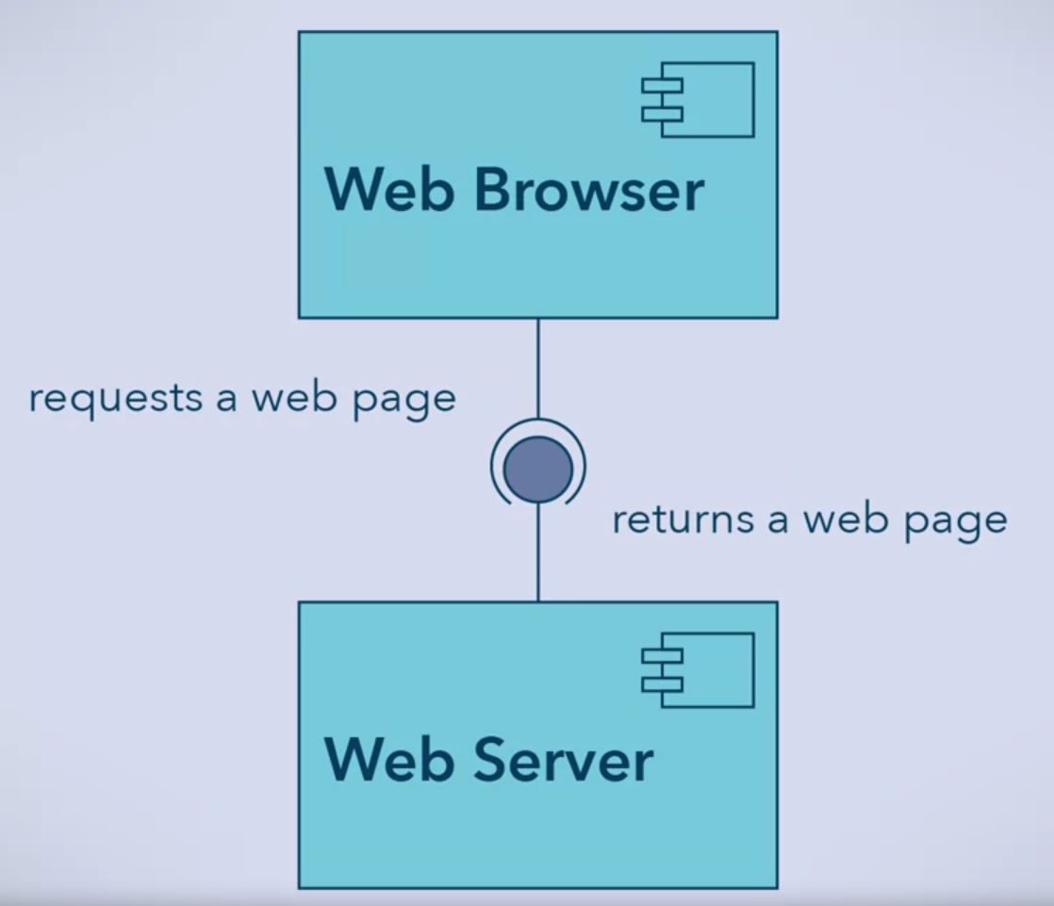

Static Web Page

* HTML Document in the web server
* For viewing only

Dynamic Web Pages

* 1993 emerges
* Does not exist on the server beforehand
* Requests its content

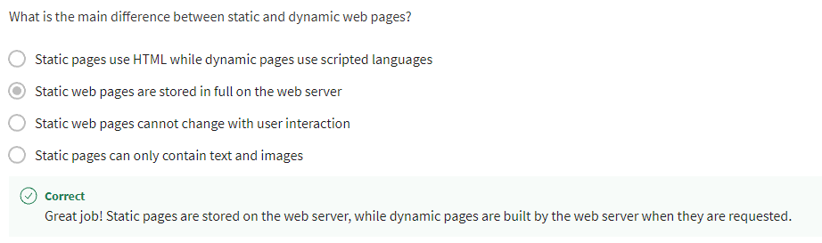

Advantages of Dynamic Website

* Customized for the viewer
* Respond to external events
* Provide more functionality
* Easier for a developer to modify

How to determine if static or dynamic?

* Do the contents of the web page change depending on when you visit the site?
* Do other people visiting the same web page see different content than you?
* Do you need to provide extra information, such as a login, before you access the web page?

If yes, dynamic!

Desktop Applications

* Stored and run locally in computer

Web Applications

* Like desktop applications
* Run in web browser and stored in remote web server
* Platform independent
* Always require internet access

Examples of Web Services

* Stock market data
* Weather reports
* Currency conversions

They communicate using:

* HTTP
* XML
* JSON

There are services that comes with an UI too

